Catch the ball

Overview

“catch the ball” is a basic 2d arcade game to demonstrate the overall flow of a game using python and simpleGE

The Game premise: the game consists of bike png, bike which appear near the bottom of the gameplay screen with a background image of the bg.png . the user can move bike from left to right with the corresponding arrow keys. A series of ball will be dropping from the top of the screen within the pg.png each ball will fall from a different x position, and at a different speed between 3 and 8 pixels per frame straight down. If bike touches a ball, a positive sound effect is played, and the player score increased if a ball leave the bottom screen, or collide with the bike, it reset to a new random position at the top of the screen

The game continue for a set period of time (ten seconds )

When the game begins, it will show an intro screen with instructions and two buttons. The play button to begin the game and the quit button

After the player has played a round of the game it takes back to the intro screen. This will display the lastest score, motivating the player to play again

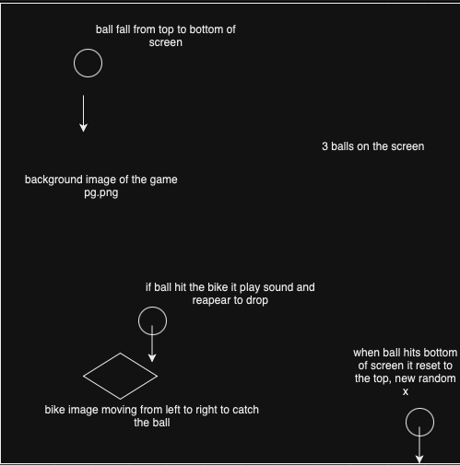

Algorithm:

1. Intialize the game

Set up the game background

Load images and sounds needed for the bike, ball, background and sound

Initialize the game environment

1. Display instruction

Show the game instructions and the last score to the player

Wait for player input to either start the game or exit

1. Start game

Create and display the game scene with the background image

Place the bike sprite at a starting point at the bottom of the screen

Initialize and place a set number of ball sprites at random position at the top of the screen

Set the game timer and score to their starting values

1. Game loop:

Process user input to move the bike left or right

Update the positions of the ball sprites, making them move down ward

Check for collision between the bike and any of the balls

Update the game timer and score display

Refresh the screen with the updated positions of all sprites

1. End game

Display the final score to the player

Prompt the player to play again or exit.